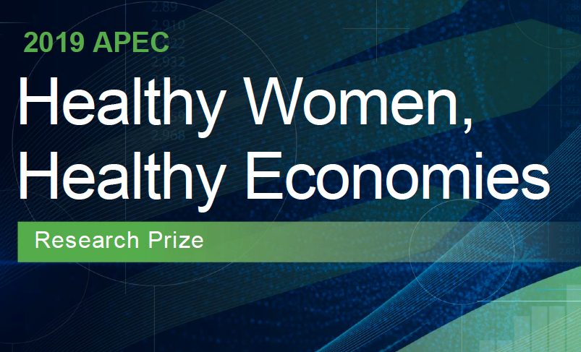

Dear Senior Colleagues,

The inaugural APEC Healthy Women, Healthy Economies Research Prize is now accepting applications for outstanding research that strives to improve women’s health, economic wellbeing, and inclusive growth. The winning entry will receive USD $20,000 and two runners-up will receive USD $5,000 each.

Please forward this message to your colleagues and students who are interested in women's wellbeing, workforce, and gender-based research.

[Theme]
The prize aims to highlight and spur the creation of sex-disaggregated data and gender-based research that will help decision-makers make more evidence-based policies to improve the lives of women and strengthen the regional economy.

Based on The Healthy Women, Healthy Economies Policy Toolkit, the five research topics are:
- workplace health and safety
- health awareness and access
- sexual and reproductive health
- gender-based violence
- work/ life balance

[Requirement]
Individuals must submit an original piece of research that is no older than two years as of January 1, 2019. Applicants may be individuals or teams (with one leader listed) who are from an APEC economy. No academic background required.

The research must be evidence-based and addresses at least one of the topics outlined in the toolkit. The research must be submitted in English.

Find out the full requirement here:
https://www.apec.org/healthywomen/HWHE_Prize
Must be an APEC member economy.

[Submission & Deadline]
To submit your application form, click here:
https://www.apec.org/healthywomen/HWHE_Prize
The deadline to submit applications is July 5, 2019.

[Prize]
The winner of the prize will win USD $20,000, while the 2 runners-up will win USD $5,000 each. If the winner or runner up is from government then the prize money will be given instead to NGOs. See details at that website.

The top three finalists will have the opportunity to present their research to members of the APEC Women and the Economy Forum in La Serena, Chile. The prize winner will be announced at the annual Women Leaders’ APEC Roundtable during the 2019 APEC CEO Summit in Santiago, Chile in November 2019.

APEC CEO Summit is Asia-Pacific's most influential meeting of business and government leaders.

[Contact]
For more information, please visit the APEC Healthy Women, Healthy Economies website.
Contact HWHE@crowell.com with any questions.

